
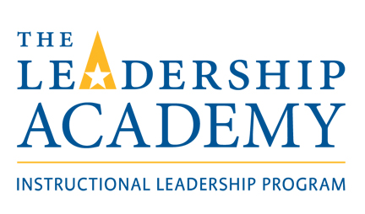

Contract Employment Opportunity

Instructor for ILP Course 6:
Developing A Community of Practice
Instructional Leadership Academy

Position Title: | Instructor for ILP 6: Developing a Community of Practice, in the Instructional Leadership Academy, for the winter term, 2021.
Course Description: ILP 6: Developing a Community of Practice | Course content focuses on understanding the characteristics and components of professional learning communities (PLCs) and collaborative learning teams (CLTs); developing strategies for initiating, moving, and sustaining PLCs and CLTs; developing strategies for teacher learning (study groups, peer visitation, coaching, action research, networks); and developing learning plans for the school. The course also attends to knowledge and skill building related to culture shaping and leadership factors that help to build professional learning communities.
Overview/Description of and Responsibilities associated with Position: | - Preparing and facilitating each of the six classes.  - Noting attendance and contacting participants if there is an absence, and communicating make-up requirements.  - Assessment of assignments and practicum experiences.  - Assigning a final grade for each participant.  - Submitting grades to Sue LeBel, ILA Program Coordinator, and Karen Turner, ELC administrative assistant, within 10 business days after the end of the course.  - Liaising with Sue LeBel regarding questions or issues that may arise.  - Meeting with Sue LeBel before the course begins for a course orientation.
Specifics | - Cohort 8: Double Cohort, consisting of 44 participants  - The course will be taught online through Zoom, with the cohort of 44.  - Dates for ILP Course 6:  - Class 1: Jan. 9, 2021  - Class 2: January 23, 2021  - Class 3: February 6, 2021  - Class 4: February 20, 2021  - Class 5: March 6, 2021  - Class 6: March 27, 2021
Reporting to: | Sue LeBel, ILA Program Coordinator
Relevant Experiences | - Previous experience teaching graduate courses at the university level or within the ILA program considered an asset  - Graduate of the ILA program considered an asset  - Strong instructional leadership at the school level  - Instructional leadership experiences at the provincial level and/or regional level  - Relevant experiences leading and facilitating collaborative learning teams and professional learning communities  - Experience using online platforms to teach, preferably the ZOOM platform  - Experience using Google Drive, developing and using shared folders  - Experience adapting activities for an online/digital platform  - Experience developing PowerPoints/Google Slides
For additional information and/or details about the position: | Please contact Sue LeBel, Program Coordinator, Instructional Leadership Academy, at 902.354.8134 or by email: slebel@nselc.ca.
How to Apply/Express Interest: | Complete the attached Expression of Interest Form and email to Karen Turner at kturner@nselc.ca.
Remuneration: | $7,000.00 per Cohort 8 group, plus HST, if applicable.  Total: Two cohort groups = $14,000 plus HST, if applicable.
Deadline to Express Interest: | November 26, 2020.

